ILLNESS REPORT

Cold: Mild, no temperature, feeling okay. If there is no other symptoms and the discharge from the nose is clear, then your child may attend school. | Conjunctivitis (Pink Eye): Suspected redness or discharge from one or both eyes. Very contagious. Your Child will need to be on medication for 48 hours and have a doctors release before returning to the school.
Fever: If your child has a fever of 37.5 or higher after adding a degree under the arm, then you must keep your child at home for 24 hours or until the fever subsides (without medication) | Ear Infection: Suspected, complains of ear hurting. Needs to be on medication and have a normal temperature with no pain before returning to school.
Sinus Infection: Greenish discharge from the nose might be a sign of infection. Child needs to stay home until gone or return with approval from your doctor. | Head Lice: IF we detect the nits or lice you will be required to pick up your child. Child may return after he/she has been treated with a medicated shampoo and all the nits are removed.
Coughing: If the Cough is minor your child may attend school. | Allergies: Runny nose and slight congestion. Your child may attend school.
Coughing: If the cough is chronic, deep, or hacking, it might mean infection. Child needs to stay home until gone or return with approval from your doctor. | Vomiting: Chronic. Your child vomited more than one time today. Child must be kept at home for 24 hours after last vomit.
Sore Throat: If mild, child may attend school. | Flu: Child must be kept at home for 24 hours after last symptom.
Sore Throat: You might need to seek advice from your doctor. Could appear to be one of the following: Swollen tonsils or glands, hurts when swallows. Child needs to stay home until gone or return with approval from your doctor. | Vomiting: Mild. Your child only vomited once. Your child may attend school.  Diarrhoea: After the third really loose stool, or if hard cramping. Child must be kept at home for 24 hours after last episode.  Hand, Foot and Mouth: Your child needs to stay at home for 7 days. Need to have a doctors note that all is clear before attending school.
Stomach Ache: Light stomach ache, no diarrhoea, vomiting or temperature. Feed light foods. Child may attend school.
Stomach Ache: Vomiting, severe cramping. Child must be kept at home for 24 hours after last episode.
 | 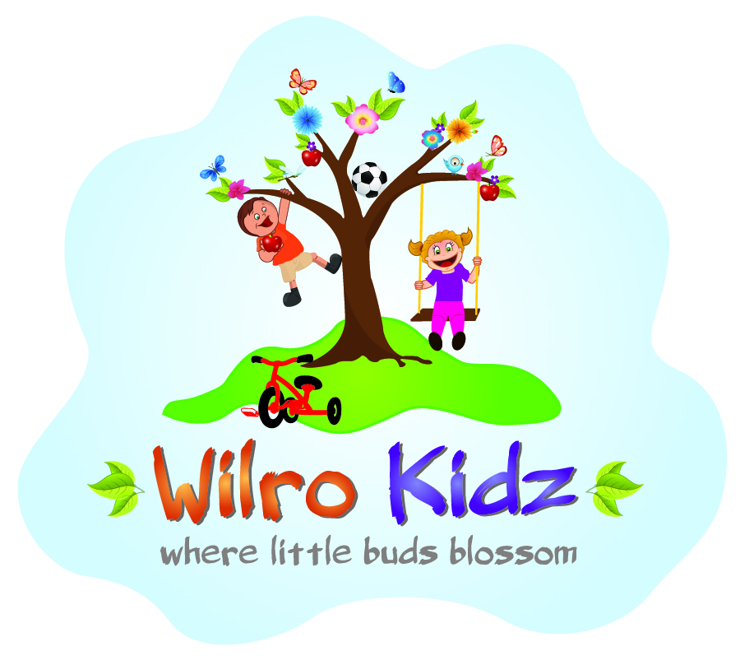
Ringworm: Ringworm is a fungal infection which is visable on the surface of the skin. Its normally in a circular or oval shape. Once scratched open the ringworm is extremely contagious and can spread to other parts of the body or other children. Child needs to stay home until gone or return with approval from your doctor.

