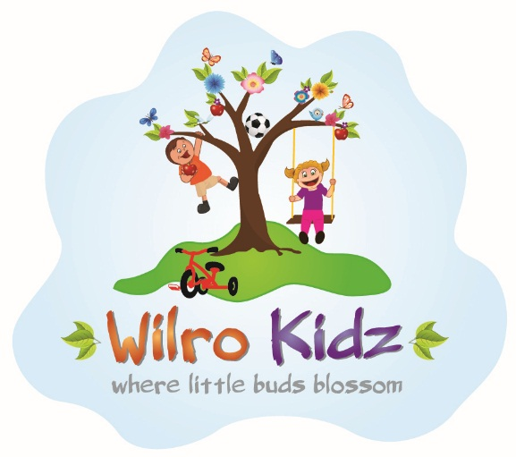

**YEAR PLANNER FOR 2023**

**\*\*\*IMPORTANT DATES TO REMEMBER\*\*\***

PLEASE NOTE: Wilro Kidz are closed on Public holidays, weekends and “specific” days as per the below.

|  |  |  |  |
| --- | --- | --- | --- |
| **MONTH** | **DATE** | **DAY** | **EVENT** |
| January | 10th | Tuesday | School Opens |
| March | 20th | Monday | School Closed – As per Enrolment Form |
| March | 21st | Tuesday | Closed – Public Holiday – Human rights Day |
| April | 7th | Friday | Closed – Public Holiday – Good Friday |
| April | 10th | Monday | Closed – Public Holiday – Family Day |
| April | 27th | Thursday | Closed – Public Holiday – Freedom Day |
| April | 28th | Friday | School Closed – As per Enrolment Form |
| May | 01st | Monday | Closed – Public Holiday – Workers Day |
| June | 16th | Friday | Closed – Public Holiday – Youth Day |
| August | 09th | Wednesday | Closed – Public Holiday – Women’s Day |
| September | 25th | Monday | Closed – Heritage Day Holiday |
| December | 15th | Friday | School Closes for the year at 12h30 |

**IMPORTANT NOTE: These dates are subject to change as per government notice.**